Title of Proposal in Initial Capital Letters:
Times New Roman (18 point Boldface)

Name 1
Name 2
Name 3
Name 4
Name of Design Team
Department Affiliation, Penn State

Submitted to—
Name(s) of Project Advisor or Sponsor
Department Affiliation, Penn State

Contents

Executive Summary 3

Statement of Problem 4

Objectives X

Technical Approach X
Identifying Needs of Customers X
Identifying Target Specifications X
Generating Design Concepts X
Selecting Design Concept X

Project Management X
Deliverables X
Budget X
Communication and Coordination with Sponsor X
Team Qualifications X

Conclusion X

References X

Appendix A: Résumés of Team Members X
Name 1 X
Name 2 X
Name 3 X
Name 4 X

Executive Summary

In a half page or less, summarize the main reasons for performing the design and the scope of the design that your group attends to achieve. Typically, all the sentences in a proposal’s summary can be found in one form or another in the sections that follow. The purpose of the Executive Summary is to give the reader an overview of what the design need is and what design is being proposed to fill that need. Because of its content and location, this section is the most widely read section of the document. For that reason, the section should be well written and carefully proofread.
Headings of sections are 14 points, flush left, and boldfaced. Use initial capitals. A good typeface for the heading is Arial, because it holds boldfacing well. To preserve hierarchy, allot two line skips before the heading and one line skip after. For a persuasive document such as a proposal or formal report, your paragraphs should average about 6-10 lines. You may have an occasional short paragraph (fewer than 6 lines) and an occasional long paragraph (11-15 lines). Be careful about having paragraphs that go more than 15 lines.
Indent all paragraphs. Scientific American, National Geographic, and all major book publishers in engineering and science indent paragraphs. You should do so as well, unless the output form of the document, such as email or the World Wide Web, does not support a paragraph indent. Also, you may place a small amount of space, such as 6 points as in this document, between paragraphs, but you probably should not place more spacing than that. Too much vertical spacing between paragraphs upsets the visual hierarchy for the headings and subheadings.

Statement of Problem

This section, sometimes called the “Introduction,” establishes the need for your design. Granted, your main audience in the proposal, the advisor of your project, understands the need, but that audience is not yet convinced that you fully understand the need. In this section, you will make assertions about the problems that have created the need for the design you are propoing. In your senior design course, those problems will range from reducing pollution to helping victims of spinal injuries to improving the durability of parts in gas turbine engines. Do not just make the assertions—rather, back up the assertions with evidence. That evidence generally will be reference listings from journal articles, books, or other sources that are well respected. An example would be Houghton and Woodwell [1]. The evidence could also be surveys or testimonies of users.
In this section, you typically do not discuss the design solutions that you propose. Rather, you establish the problem or problem so that when you discuss the proposed designs in the following sections, the reader is prepared. Please indent all paragraphs and do not skip a line between paragraphs in the same section or subsection. Rather, you may place a little space between paragraphs as done in this template (6 points), but you probably should not place more spacing than that.

Design Objectives

This document proposes…here you formally state what you propose to design. Often, the design has two to four specific objectives. These you might consider listing vertically as follows:
(1) first design objective,
(2) second design objective, and
(3) third design objective.
A reason that a vertical list is appropriate here is that readers often return to this section to review those objectives. Having the objective in a vertical listing makes it easier to find. If your design objectives are complicated and depend on variables, consider placing them into a formal table, which would be introduced by name: Table 1, Table 2, and so forth.
In this section, you would present text that discusses more fully what you mean by the different design objectives. That explanation would include a discussion of not only what you intend to do, but also a justification of what you will not do (in other words, what your audience might assume that you will do). You might consider having a paragraph for each objective. Adopt the same paragraphing format as discussed in previous sections.
Note that if you have done a good job in the “Statement of Problem” section, then all the design objectives should make sense to the audience. Avoid having more than four objectives. Lists more than four are often not read. To avoid having more than four, you might consider grouping two or more objectives.

Technical Approach

This section discusses how you will obtain the objectives presented in the previous section. This plan should follow a logical sequence. One such sequence is given in the subheadings below. Please make sure that you have a transition paragraph between the heading “Technical Approach” and the subheading “Identifying Customer Needs.”

Identifying Customer Needs
Here you would place paragraphs that explain how you identified the needs of the customer or how you will identify the needs of the customer. Adopt the same paragraphing format as discussed in previous sections.

Identifying Target Specifications
Here you would place paragraphs that explain how you targeted the specifications or how you will target the specifications. Adopt the same paragraphing format as discussed in previous sections.

Generating Design Concepts
Here you would place paragraphs that explain how you generated the design concepts. Please identify all of your design concepts in this subsection. You might consider placing those concepts into a table with one column giving a short summary of the concept. Adopt the same paragraphing format as discussed in previous sections. In this subsection, you should probably discuss at least three concepts, giving perhaps a paragraph to each.

Selecting Design Concept
Here you would place paragraphs that explain how you selected the design concept. In addition, you should also identify what alternative design concepts you have selected for the project. Adopt the same paragraphing format as discussed in previous sections.

Project Management

This section presents the plan for managing the project. This plan should follow a logical sequence. Please make sure that you have a transition paragraph between the heading “Project Management” and the subheading “Deliverables.” That paragraph should introduce and explain your Gantt chart for the project. An example of such a chart appears in Figure 1.
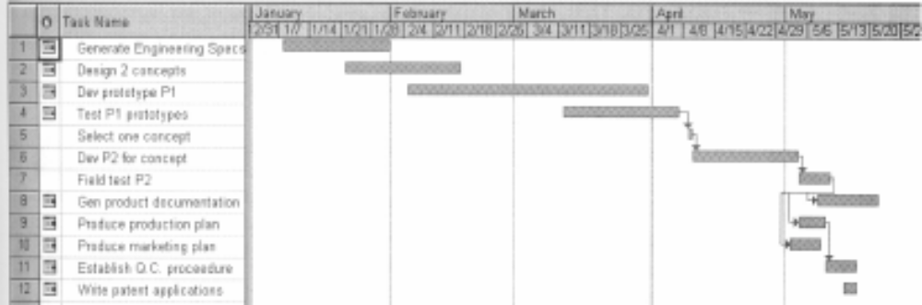

Figure 1: Gantt chart for the project. The solid bars indicate the portions of the tasks that have been accomplished.

Deliverables
Here you would place a paragraph or paragraphs that present the deliverables that you will provide the customer. Adopt the same paragraphing format as discussed in previous sections.

Budget
Here you would place a paragraph or paragraphs that explain the budget for the project. Include a table such as Table 1. Adopt the same paragraphing format as discussed in previous sections.

Table 1: Requested items and funds for initial design.
Item | Supplier | Catalog No# | Quantity | Unit Price | Total
Vacuum Pump | McMaster Carr | IJ-60825 | 1 | $183.47 | $188.72
Flow Pump | Northern Tool | CJX-689 | 1 | $139.99 | $156.62
23/32" Plywood 4'x8' | Lowe's Hardware | none | 1 | $24.95 | $24.95
4" Ondine Rainmaker | Smartbargain.com | 129808 | 1 | $19.99 | $37.86
Acrylic Tubing 5' (OD 8") | McMaster Carr | 8486K626 | 1 | $236.70 | $250.95
"8" Flange (13" OD) | McMaster Carr | KD-ERW | 1 | $44.24 | $44.24
 |  |  |  | Total | $703.34

Communication and Coordination with Sponsor
Here you would place paragraphs that explain how you will communicate and coordinate with your sponsor. Adopt the same paragraphing format as discussed in previous sections.

Team Qualifications
Here you would place a paragraph that introduces the qualifications for the team and refers to the resumes located in Appendix A. In this section, you should provide a paragraph for each team member. Adopt the same paragraphing format as discussed in previous sections.

References

1. Houghton, Richard A., and George M. Woodwell, “Global Climatic Change,” Scientific American, vol. 260, no. 4 (April 1989), pp. 39–40.
2. Fox, R.W., and A.T. McDonald, Introduction to Fluid Mechanics (New York: John Wiley & Sons, 1978), pp. 242–245.
3. Varian Corporation, "Smithsonian Researchers Use High-Tech Digital Imaging Device to Study Collections," http://www.varian.com/ (Palo Alto, CA: Varian Corporation, 13 February 2002).

Appendix A:
Résumés of Team Members

The following pages present one-page résumés of the team members for this project.

